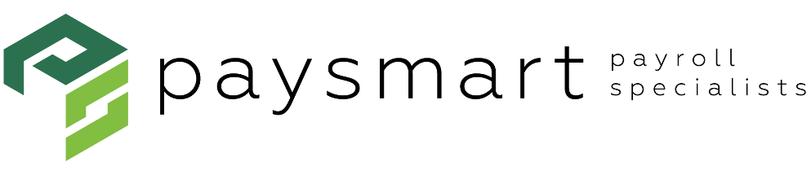
Email Subject Line: How to Customize Questions in FLIGHT

Your Very Smart payroll tip for February 16:

You can add specific questions for employees in FLIGHT.

FLIGHT gives you the flexibility you need to add customized questions to your FLIGHT library. Here’s how.

- Go to “New Hire(s)” then to “+Add New.”

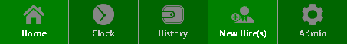

- As you go through the new hire setup, the option to add custom questions will be in the “Questionnaire” section.

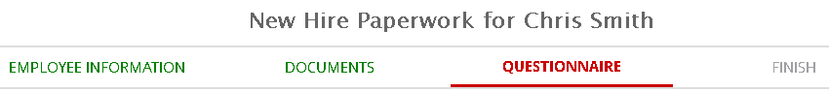

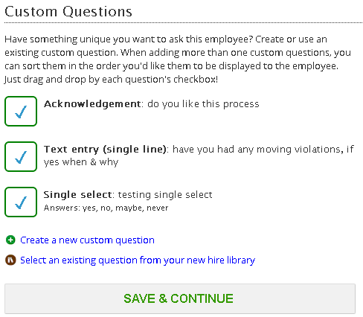

- Enter your question; select the type; click “Add Question.”

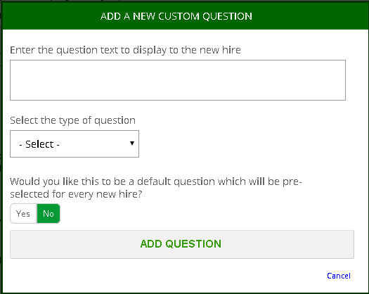
Question Types:

Text Entry
Text Entry (multi-line)
Yes/No
Single Select
Acknowledgement

- Click “Save & Continue.”

Your Next Very Smart Tip:
Your February 23 Very Smart Tip will show you how to add a company document in HUB.

