Email Subject Line: Adding Mileage & Expenses in HUB

Your Very Smart payroll tip for August 24:

Employees can now add a one-time pay to their timesheet for mileage and expenses.

1. Log into HUB and go to “Admin.”

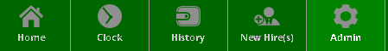

2. Go to “Payroll Lists” to define which pay codes an employee can enter for one-time pays.

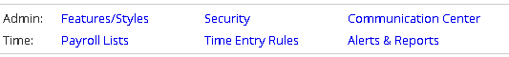

3. Click “edit” for the pay code you want.

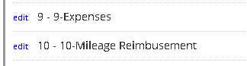
4. Go to “Prompts.” Select the Collection Type and whether the employee should be prompted at clock out. Enter any prompt text now.
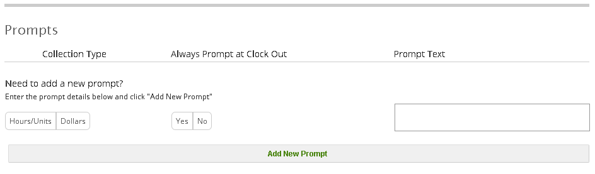
Enter the prompt text you want displayed to the employee here.

5. Select “Add new prompt.”

6. The employee can then enter their one-time pay items when prompted or by clicking on the circle with their intials in the upper right hand corner of the HUB homepage.

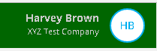

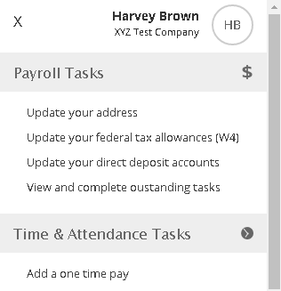

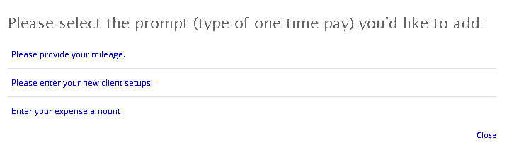

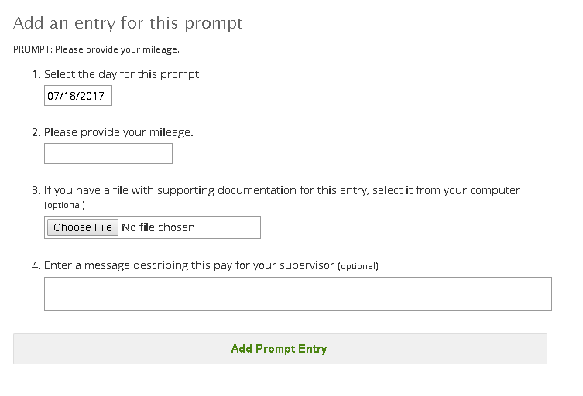

7. The pay item is now on the employee’s time sheet.

If you don’t have HUB, contact PaySmart to learn more about the benefits of the employee self-serve portal.

Your Next Very Smart Tip:
Your August 31 tip will discuss who are exempt employees.

