**Email Subject Line: How to Add a Document to a Specific Employee in HUB**

***Your Very Smart payroll tip for April 13:***

**You can save time and headaches by adding employee documents in HUB. This gives you easy access to important information 24/7, without maintaining a paper file. Follow these easy instructions to get started today.**

*If you currently only have a hard copy of the document, you’ll need to scan and save a digital copy before getting started.

1. ***Starting at your HUB portal*, go to “Admin.”***



*\*If you don’t see this bar, contact your payroll specialist to get set up today.*

1. ***Select Appropriate Employee***

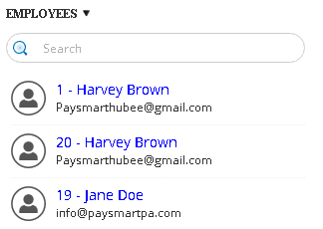

1. ***Select “Documents.”***

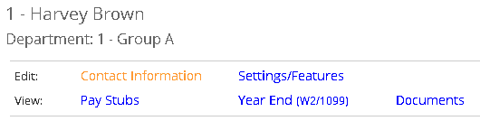

1. ***Select “+Add new document.”*** 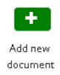

Once you’ve clicked “Add new document,” follow the prompts to add the document to HUB.

1. ***Additional Options***

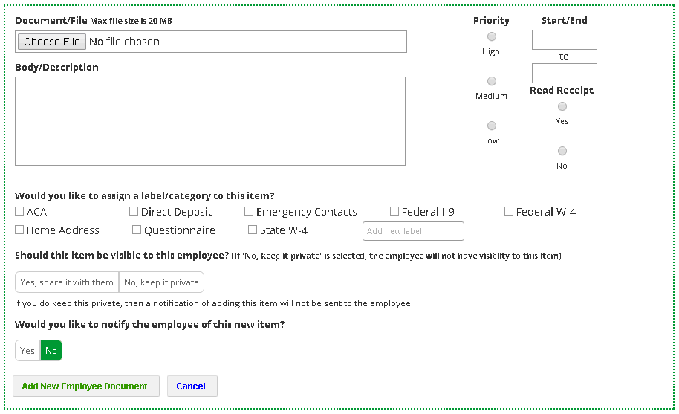

1. Have an expiration date so the document is no longer available after a period of time.
2. Request a read receipt.
3. Categorize all of your documents.
4. Keep document private from the employee or allow them to view.
5. Notify Employee of document.

**Your Next Very Smart Tip:**

Your April 20 Very Smart Tip will show you how to set up holiday hours in HUB.