Email Subject Line: Adding one-time pay in HUB

Your Very Smart payroll tip for August 10:

Need to pay an employee a bonus or another type of one-time pay? It’s easy with HUB.

1. Go to “Clock.”

2. Find the employee’s time sheet and click “Add One Time Pay.”

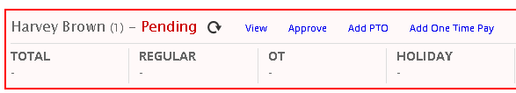

3. Fill in the information about the pay item and click “Add One Time Pay.”
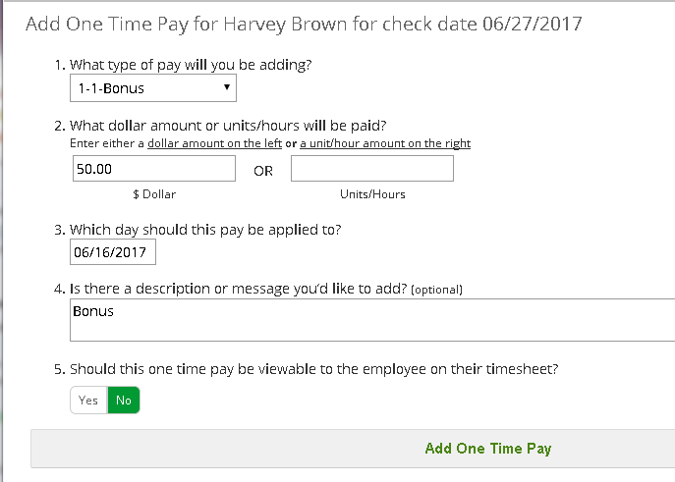

4. The pay item is now on the employee’s time sheet.

If you don’t have HUB, contact PaySmart to learn more about the benefits of the employee self-serve portal.

Your Next Very Smart Tip:
Your August 17 tip will discuss how to handle car allowances.

