Two-Factor Authentication – PPX
The following are recommended download options available for iPhone or android devices (any authenticator app will work, if already using)
• Microsoft Authenticator on the App Store (iOS devices): https://itunes.apple.com/us/app/microsoft-authenticator/id983156458?mt=8
- Microsoft Authenticator on the App Store (Android device):
https://play.google.com/store/apps/details?id=com.azure.authenticator
To activate:
- Log into PPX
- Verify email address – email address can only be registered once.
- Download Authenticator App (suggestions listed above)
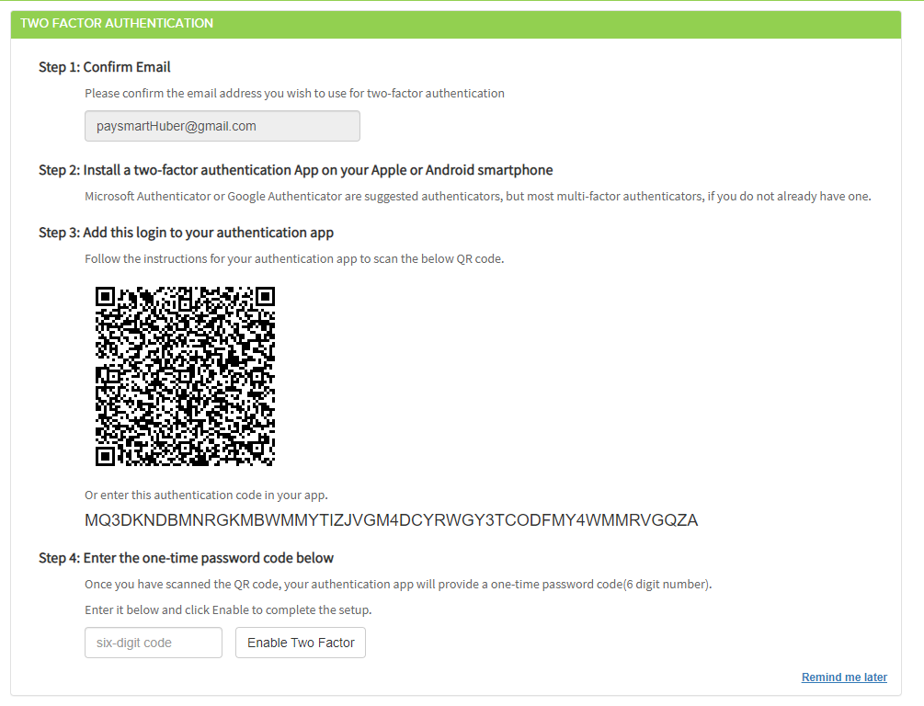
- Using the Authenticator that was downloaded to your mobile device, Scan the QR code or type the QRP code into the app (see applications above).

- Enter the 6-digit code and click Enable. (This will change to a red Disable button)
  - The Two-Factor Authentication is now registered and ready for use!
- Completely log out of PPX and log in to verify that the Two-Factor Authentication works correctly.

Important Reminders:
- Once activated, the PPX will require a 6-digit code to be entered using the app that was installed at setup after entering the password.

